EXPLORATORY DATA ANALYSIS

DATA LOADING CODE:

DIMENSIONS:

**8143** Observation

**7** Features

(for the dataset **datatraining.txt** )

Feature Details:

|  |  |  |  |
| --- | --- | --- | --- |
| NAME | FEATURE TYPE | ROLE | COMMENT |
| date | Date/Time, String | None/Identifier | Formatted according to year, month , day and then hour, minute, second |
| Temperature | Numeric,continuous | Descriptor | Feature is in Celsius |
| Humidity | Numeric,continuous | Descriptor | Feature is in percentage ( % ) |
| Light | Numeric,continuous | Descriptor | Feature is in Lux |
| CO2 | Numeric,continuous | Descriptor | Feature is in parts-per-million ( ppm ) |
| HumidityRatio | Numeric,continuous | Descriptor | Derived quantity from temperature and humidity |
| Occupancy | Integer,discrete | Response | 0 = not occupied  1 = occupied |

Class Distribution:

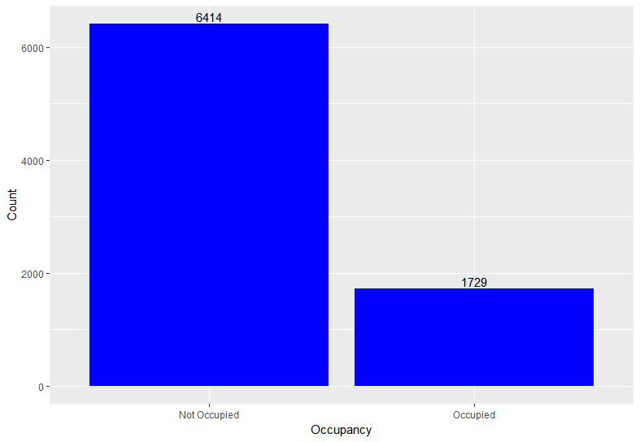

Feature value distribution:

Date:

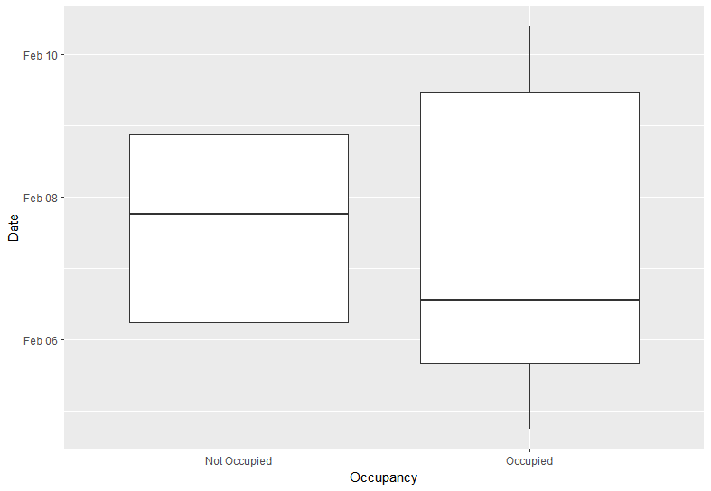

Temperature:

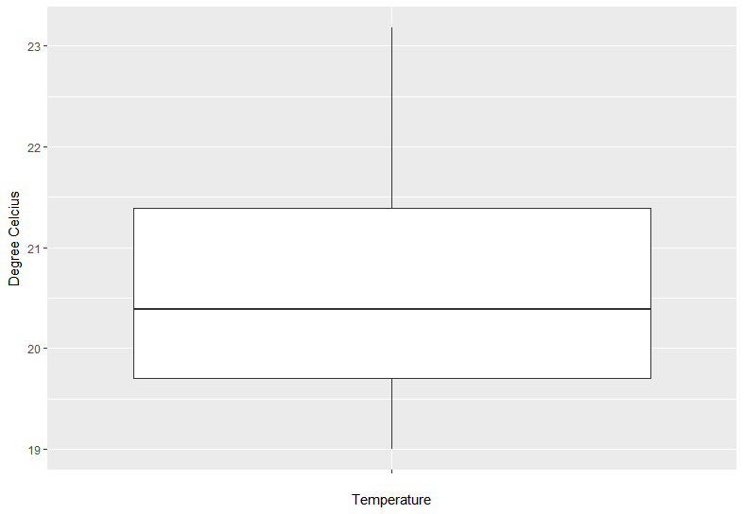

Humidity:

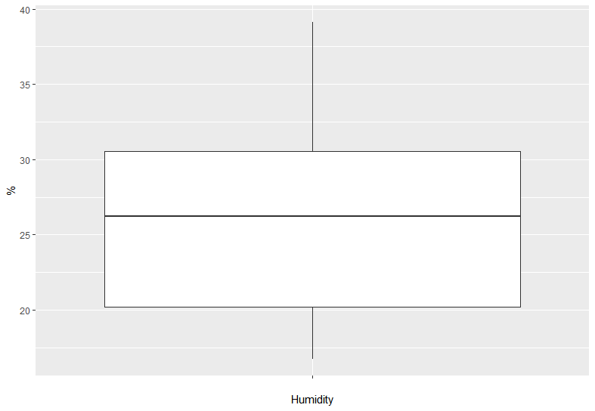

Light:

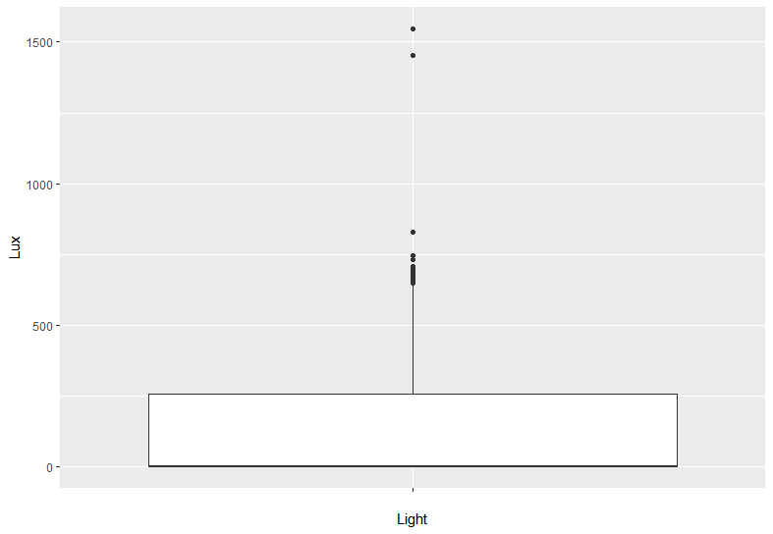

CO2:

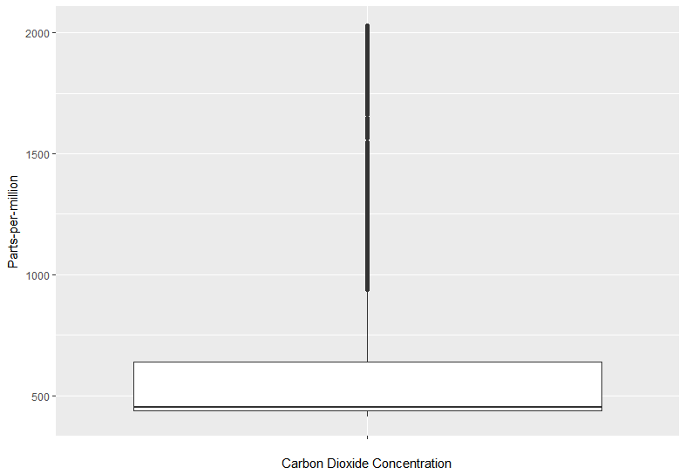

HumidityRatio:

